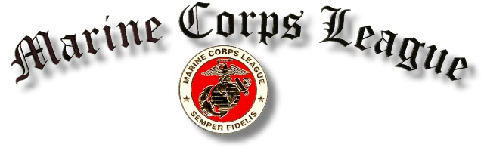

Diamond State Detachment 704

Diamond State Detachment, 704
P.O. Box 676 – Lewes, DE 19958

Minutes – January 24, 2019

Commandant Kollar called the meeting to order at 1900. Sergeant-at-Arms Mumford posted the colors and led the pledge of allegiance. Chaplain Kitchenman offered the opening prayer. Department Commandant Landon was in attendance at the meeting.

ROLL CALL OF OFFICERS

Commandant Dick Kollar Present
Senior Vice Commandant Tim Shepke Present
Junior Vice Commandant Patrick Feehley Excused
Judge Advocate Frank Barnes Present
Adjutant Tom Carter Present
Paymaster Bob Ruotolo Present
Chaplain John Kitchenman Present
Sergeant-at-Arms Kevin Mumford Present
Junior past Commandant Austin Govin Absent

MINUTES: The minutes of the December 27, 2018 meeting were accepted as published.

NEW MEMBERS: None

CORRESPONDENCE: None

WREATHS ACROSS AMERICA: Ms. Theresa Townsend, Local Coordinator for Wreaths Across America, personally thanked the Detachment for contributing $300.00 and participating in the laying of wreaths at the Delaware Memorial Veterans Cemetery in Millsboro in December. 800 volunteers placed over 2,000 wreaths on graves at the cemetery.

PAYMASTER REPORT: The Paymaster’s report was approved as presented by Corpsman Ruotolo, subject to audit.

MEMBERS SICK OR IN DISTRESS: Chaplain Kitchenman read notes from Marine Craig James and from his wife Alice.

REPORTS OF OFFICERS: None

COMMITTEE REPORTS:

Toys for Tots: Commandant Kollar reported that a plaque honoring Allen Harim will be presented to him in February for his role in making the 2018 campaign a success.

UNFINISHED BUSINESS: None

NEW BUSINESS: None

INSTALLATION OF OFFICERS: Department Commandant Landon swore in Officers for 2019. They are:

Commandant: Marine Patrick Feehley
Senior Vice Commandant: Marine Tim Shepke
Junior Vice Commandant: Marine Kevin Mumford
Judge Advocate: Marine Frank Barnes
Adjutant: Marine Tom Carter
Paymaster: Corpsman Doc Ruotolo
Chaplain: Marine John Kitchenman
Sergeant-at-Arms: Marine Rich Corbit

MARINE OF THE YEAR: The 2018 Marine of the Year presentation has been postponed until the February meeting.

GOOD OF THE LEAGUE: The moving Vietnam Wall will be on display at the Ferry terminal May 16-20, sponsored by American Legion Post 17. Marine Mansfield asked for volunteers to serve as security for the Wall during this period.

There being no further business, the meeting was adjourned by Commandant Kollar with the appropriate ceremony at 1950 followed by singing of the Marines Hymn.

Respectfully submitted,

Tom Carter
Adjutant
Semper Fidelis

CALENDAR

February 28 at 1900 – Detachment
Meeting at AL Post 28

